AI Based Discourse For Banking Industry

Problem Solution Fit

Team ID: PNT2022TMID16498

LCuslomer ge@rnenfs

*Early* detection *is ciuei'al because it will help us use* ñ’afsori’s *assistant to* 6ui’/d a *chatbai thai will help banks* aafomafe *business processes like customer* sen'icé. *This* serves a greater pvrp*ose than a manual eraminatior.*

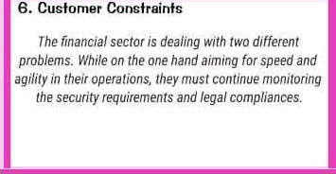

|  |  |  |
| --- | --- | --- |
| s. sobs To Be Dor+a/Problems  *Banks wil! need la* create *iniegiated* propose/s t/taf  *go beyond highly* sfandardised /fems *and câncentrate on* ’/0tIs *t0 be d0ne." This requires designing value* propositions tial*go beyond* file core d8n#iny *product, include* persona *fixation* decisions *an4 inco potztia8* intelligence Stat *alienates* decisio *us* an# actions |  |  |
|  | 7.Behaviour    *fhmvgh leaQiny by exz*rri*yl+. enJ ennnuing i'ng* desired  behaviours *like lifelong learning, knowledge stieii'ng,*  *and inner-discipline* coope/ari'og is *signiti¢antlyiesgfinsible*  for undersfand'ng *and* ronrirf•’on. |

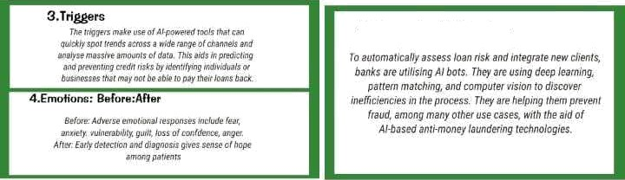

8.ChenneIn at behaufour

